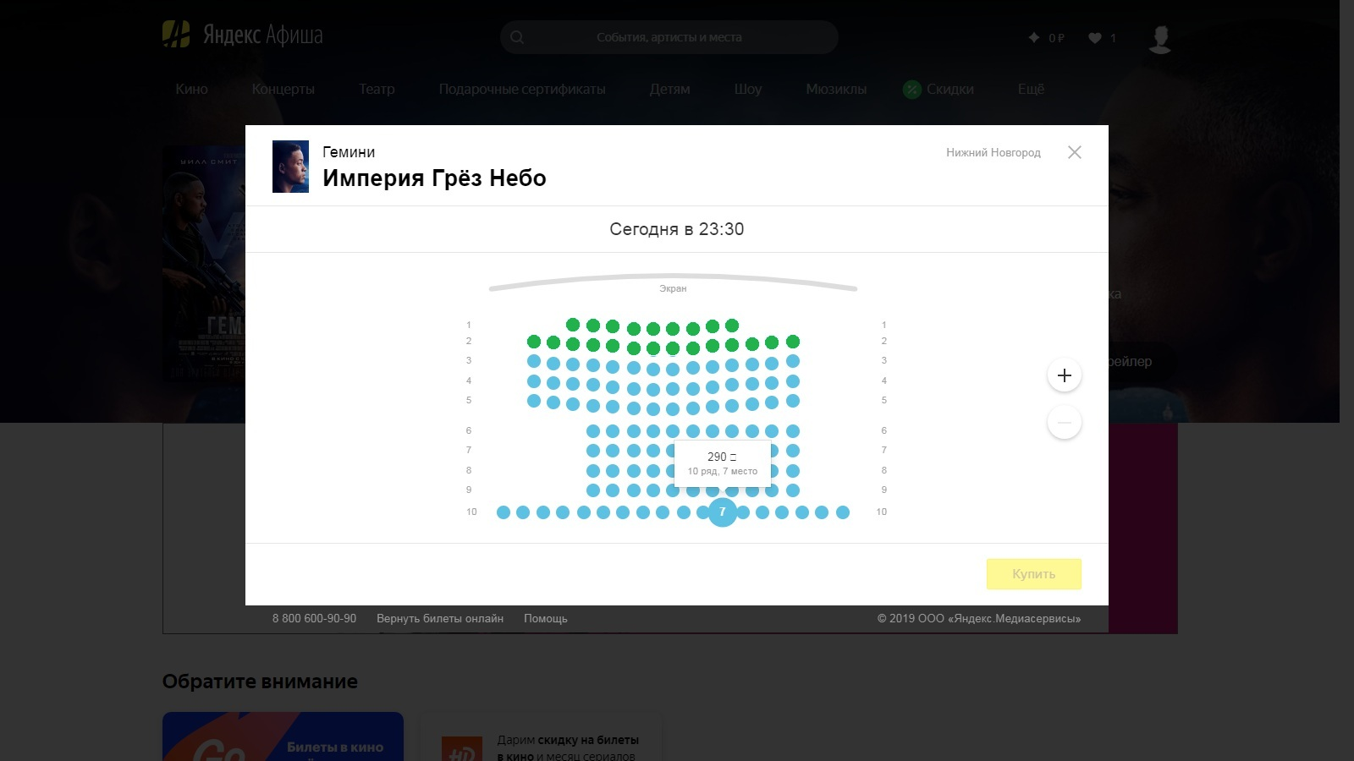

#myDescription

#myHeader

#myModal

#myOverlay